SIMATS ENGINEERING
ASSESSMENT TOOL 1: Experiments
COURSE NAME: Cloud Computing and Big Data Analytics COURSE CODE: CSA1596
COURSE OUTCOME COVERED CO3: Implement cloud-based solutions using cloud storage, web APIs, and platform services for real-world applications. (BL3)
Dave's Taxonomy: Precision (Level 3) Question Count: 4 Total Marks: 40
Code of Conduct
I Vaishali.M (192524440)(Name / Reg No) certify that this submission is my original work and that I have adhered to the guidelines specified for this assessment. I understand that any violation of academic integrity rules will result in disciplinary action. Signature of the student: Vaishali.M
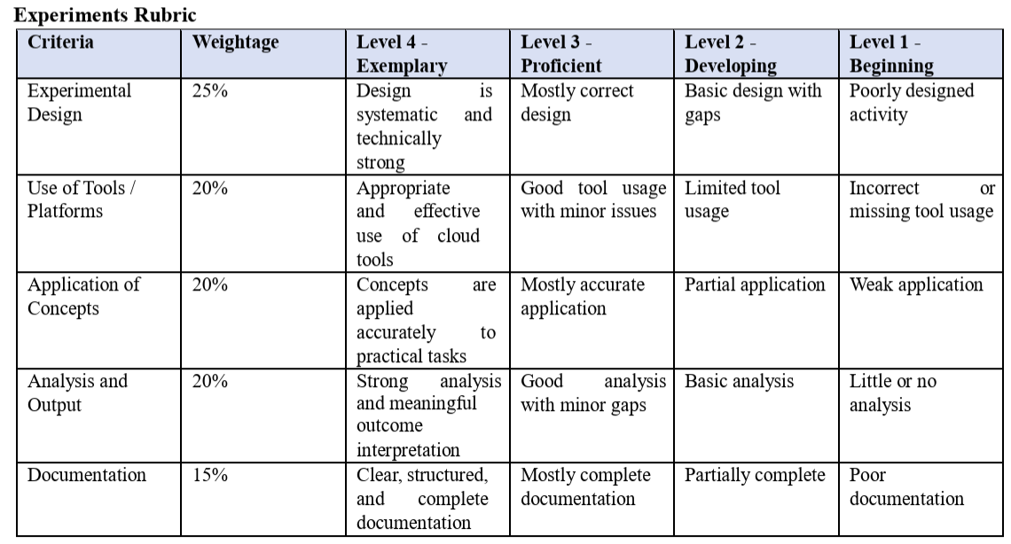

Experiment 1: Create a simple cloud software application for Library book reservation system for SIMATS library using any Cloud Service Provider to demonstrate SaaS include the necessary fields such as Title of the book, author, publications, Year, edition, no of copies, Rack no, status (taken/returned) etc.
Aim
To create a simple cloud-based Library Book Reservation System for SIMATS Library using a Cloud Service Provider and demonstrate the Software as a Service (SaaS) model.

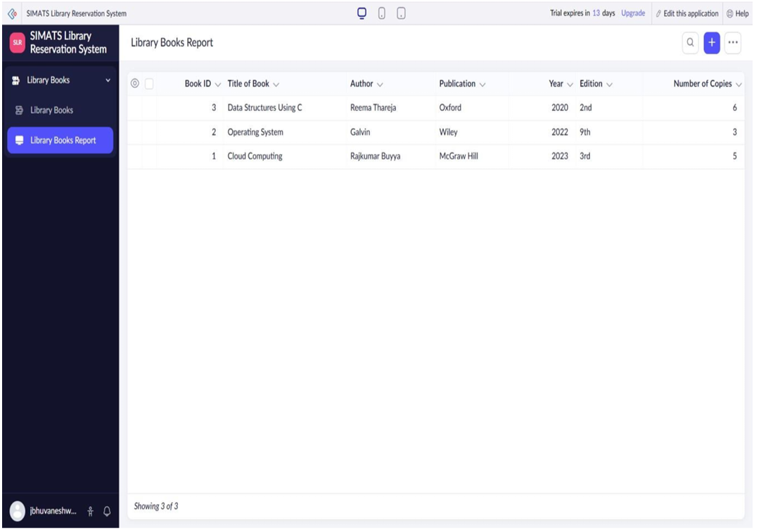

Experiment 2: Create a simple cloud software application for Payroll Processing System using any Cloud Service Provider to demonstrate SaaS include the necessary fields such as Name of the employee, experience in present org , over all experience, basic pay, HRA, DA, TA, net pay, gross pay etc.
Aim
To create a simple cloud-based Payroll Processing System using a Cloud Service Provider to demonstrate Software as a Service (SaaS).

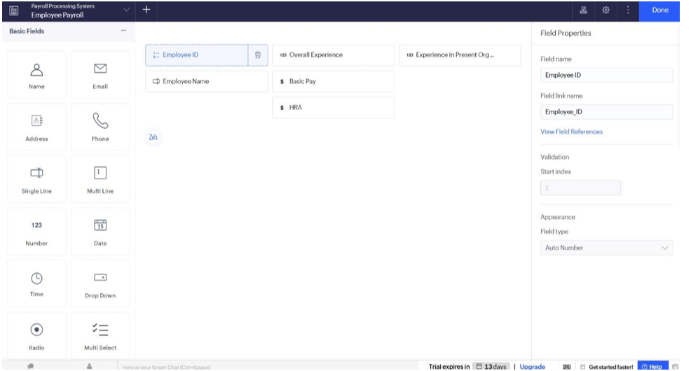

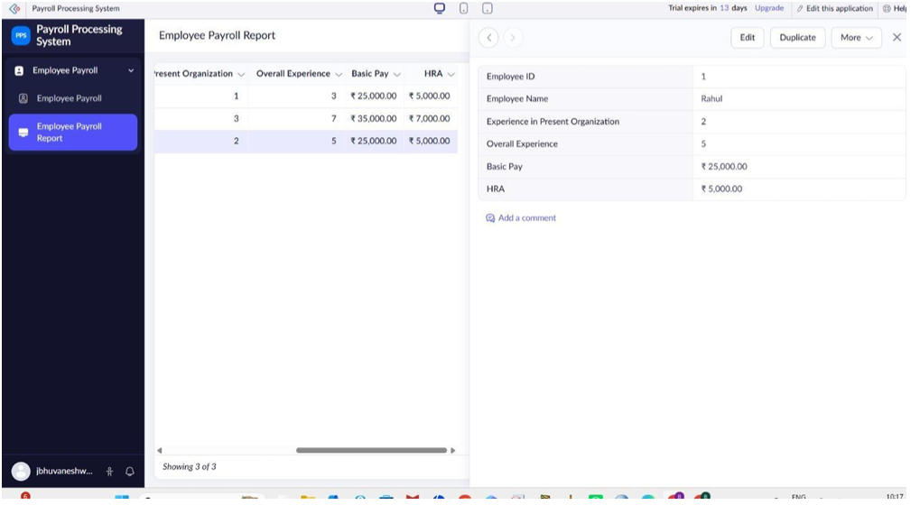

Experiment 3: Demonstrate virtualization by Installing Type-2 Hypervisor in your device, create and configure VM image with a Host Operating system (Either Windows/Linux). Create a Virtual Machine with 1 CPU, 2GB RAM and 15GB storage disk using a Type 2 Virtualization Software.
Aim
To demonstrate virtualization by installing a Type-2 Hypervisor, creating a Virtual Machine (VM), and configuring it with 1 CPU, 2 GB RAM, and 15 GB storage.

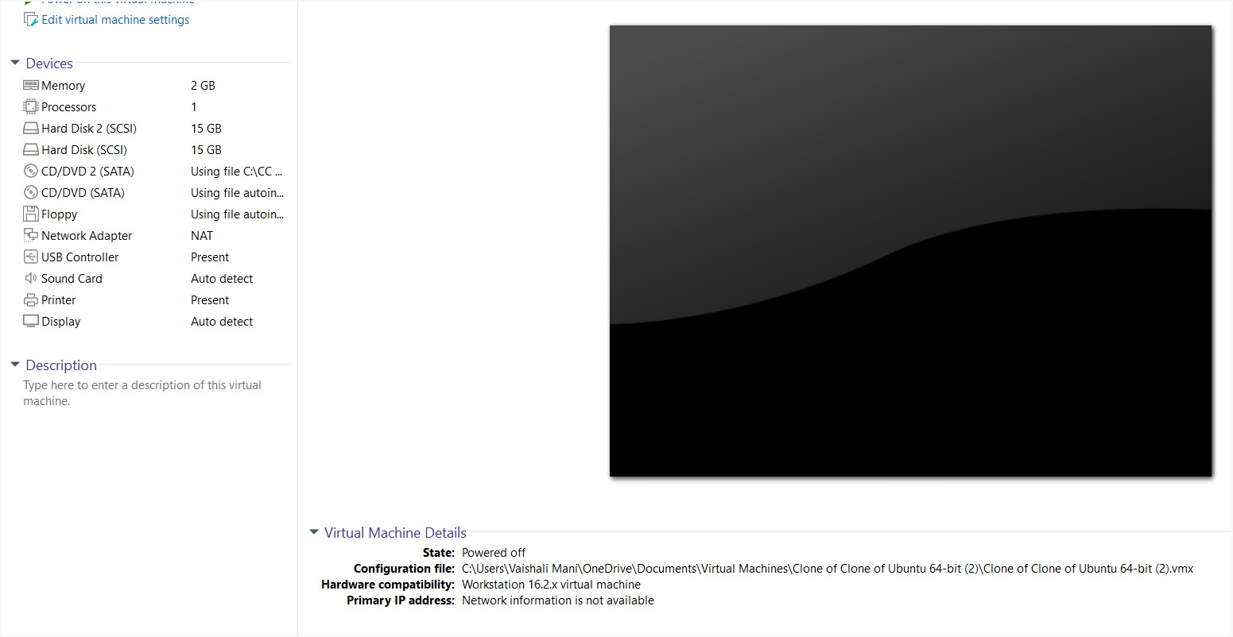

Experiment 4: Demonstrate virtualization by Installing Type-2 Hypervisor in your device, create and configure VM image with a Host Operating system (Either Windows/Linux). Create a Cloning of a VM and Test it by loading the Previous Version/Cloned VM
Aim
To demonstrate virtualization by installing a Type-2 Hypervisor on a host device, creating and configuring a Virtual Machine (VM) with Windows/Linux as the guest operating system, cloning the VM, and testing the cloned/previous version.

